Moonlite 80 Flush mount bracket installation procedure

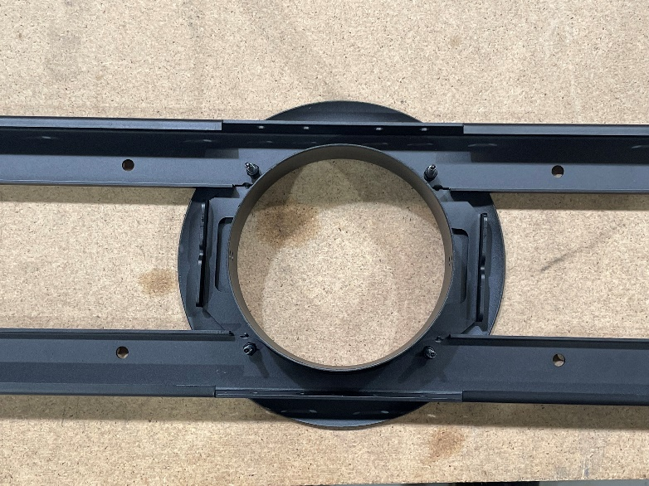
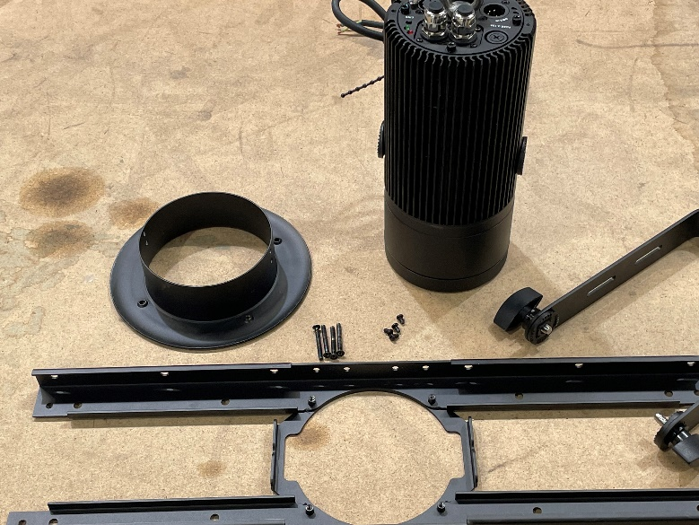
Remove bracket from wrapping

With a deep 7mm socket remove and discard the 4 nyloc nuts
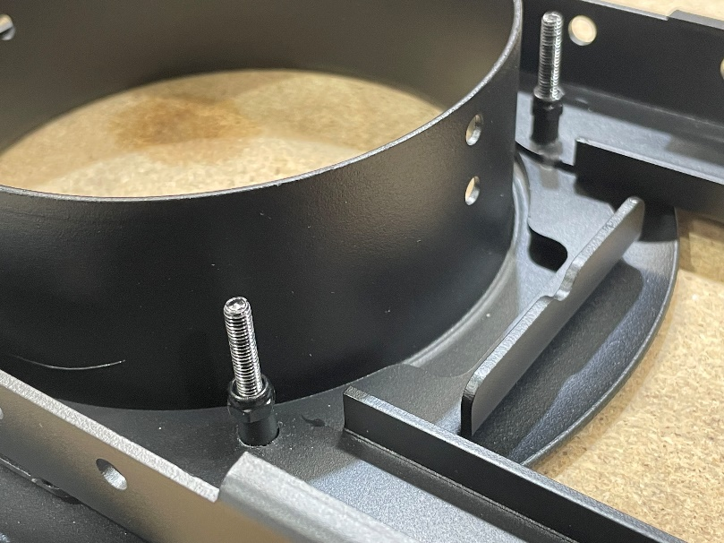
Unscrew the 4 screws completely so the facia panel is now apart from the retaining section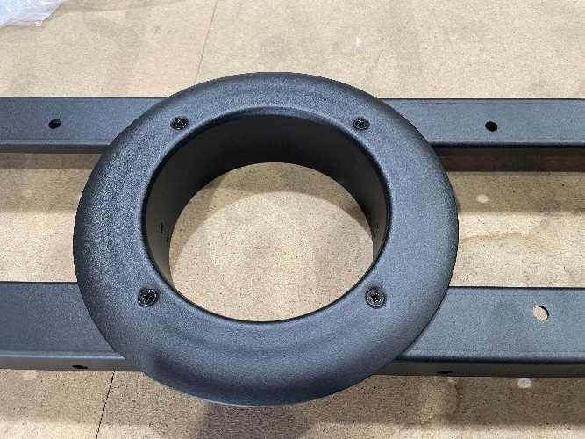

With the 4 short screws supplied fix the facia panel to the Moonlite 80 and secure tight also completely remove the hanging bracket of the Moonlite 80 and discard
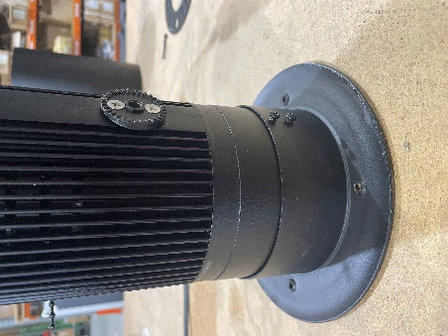
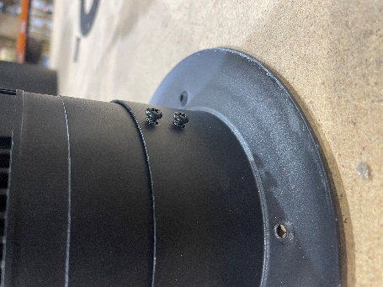
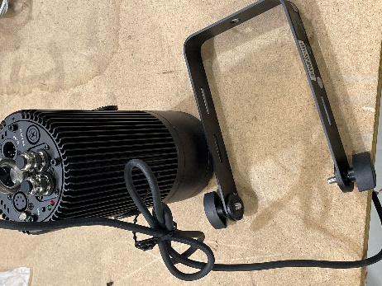

Now drill 160mm diameter hole in the surface you plan to install the fixture into
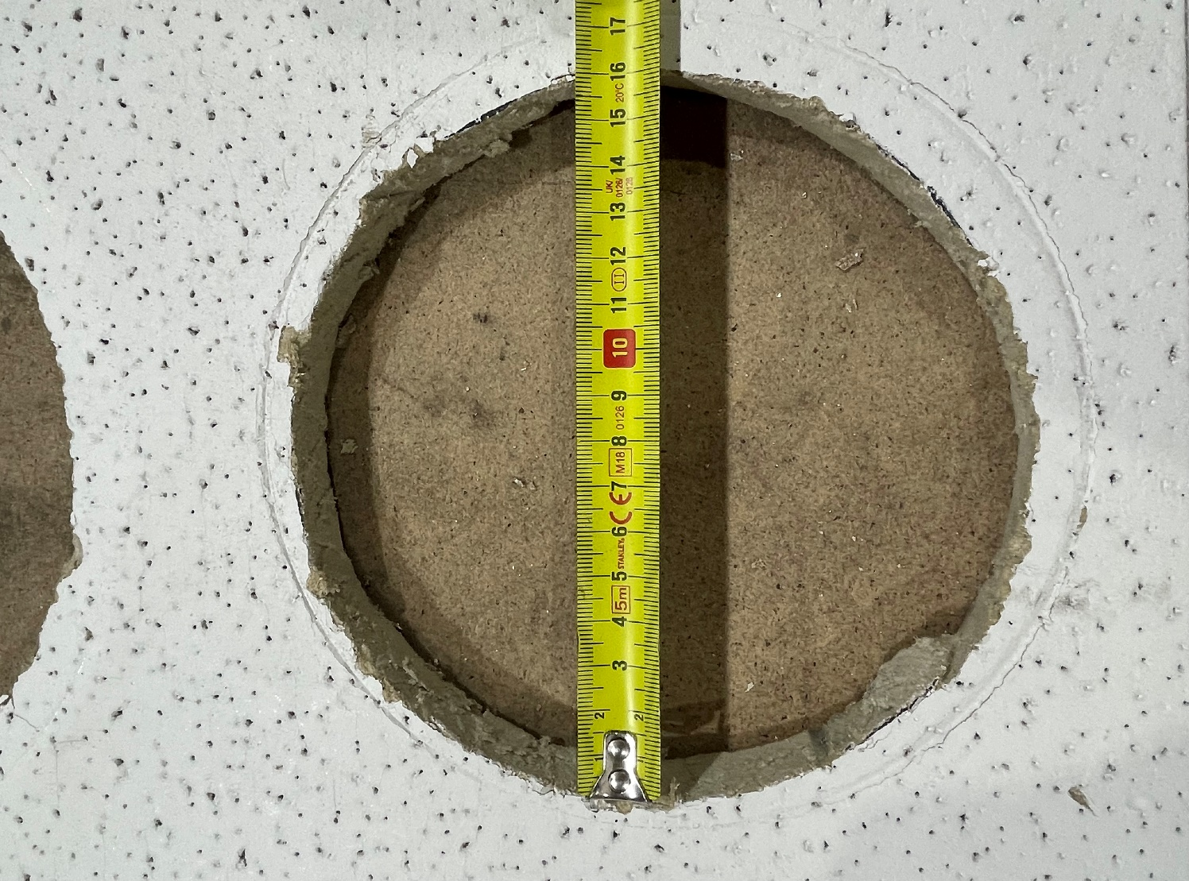

Now feed the retaining section of the bracket through the 160mm hole ensuring it is perfectly placed in the centre of the hole
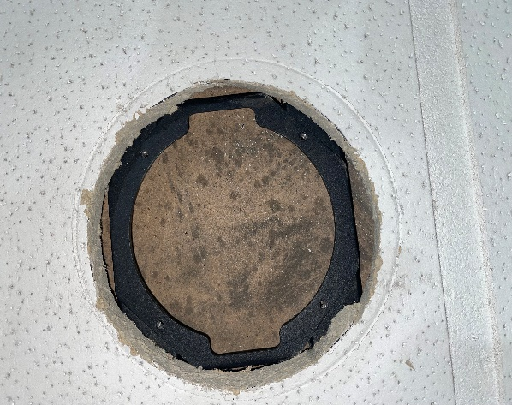

Complete your wiring of the fixture via the hole connect power and data to the Moonlite 80 and install and secure the Moonlite 80 with the 4 long screws to the retaining section.
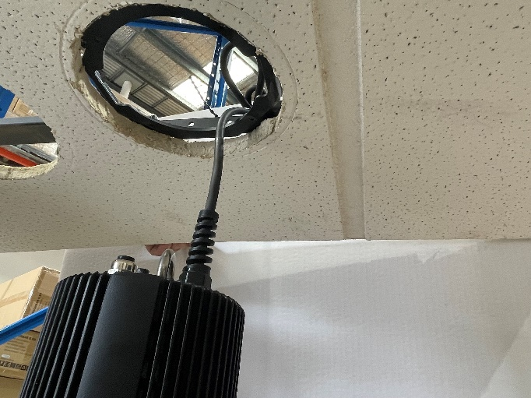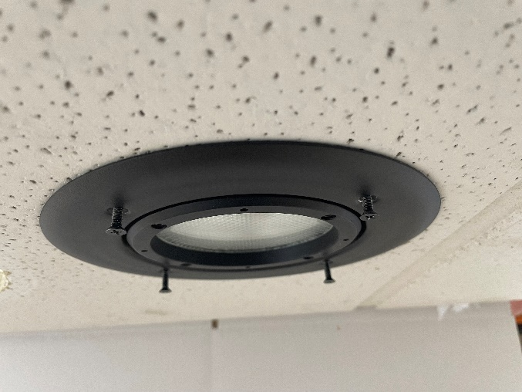

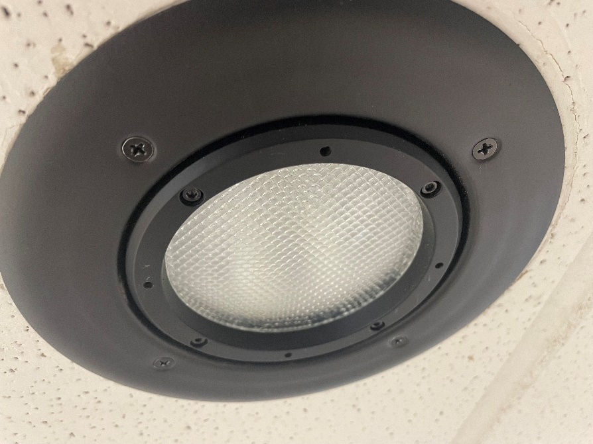
Installation complete

